Everything you Need to know about Vaping  What is vaping? Vaping refers to process of heating cannabis without burning the product. Heating the product causes the active ingrediants of cannabis to be released in the air as a fine mist of vapor. Vaping is not synonymous with smoking as smoking describes inhaling the smoke of combusted product and is known to contain harmful toxins.  There are many tools for vaporizations and even more cannabis products that can be vaporized. In this pamphlet you can find a guide to choosing the right kind of vaporizer for you, how to estimate the appropriate dose for your needs (microdosing), the different products available to vape, and includes the optimal vaping temperature of each product. |  | Medical Cannabis is Changing the Face of Clinical Medicine.  We are the Leaders of that Change |  | ideal Vape Temperatures for cannabinoids  THCA 140-257˚F  CBDA 248˚F  THC 315˚F  THCV 428˚F  CBD 320-356˚F  CBDV 824-905˚F  CBC 428˚F  CBG 445˚F  CBNA 365˚F  CBN 365˚F  Delta 8 THC 355˚F
 |  | 822 Boylston st  chestnut hill, ma 02467  617-500-3595  cedclinic.com  info@cedclinic.com |  | Check out our blog and social media handles for more information on medical cannabis.  Blog: cedfoundation.com  Instagram: drbenjamincaplan  Twitter: @drcaplan

Tools for vaping  Desktop Vaporizers  These styles of vaporizers are stationary and require access to an outlet.  Balloon Bag models are characterized by a fan blowing convection heated vapor up into a ballon that is then removed for inhalation. Whip-Style models feature a glass mouthpiece and medical grade tubing for direct inhalation of the product.  Portable Vaporizers  These styles of vaporizers are portable and the vapor is self drawn.  Variable Ovens are enjoyed by those looking to vaporize flower product and concentrates on the go.  Pens are frequently prefilled for a travelers convenience.  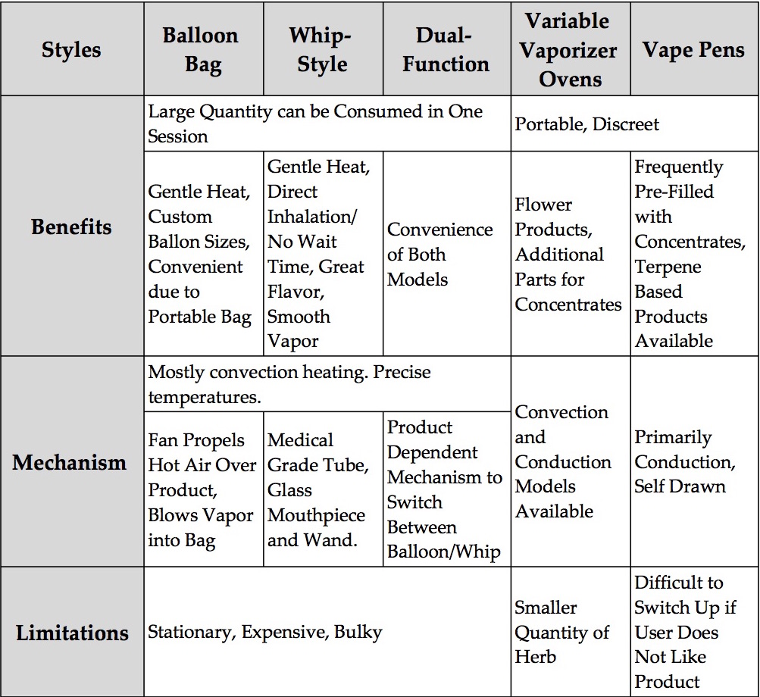  Featured below is a table describing the benefits and limitations of various vaporizers. |  | cannabis products  Flower  Flower refers to the whole plant material that is sold as dried buds. Flower product still contains all of the cannabinoids, terpenes, and flavonoids of the plant.  Concentrates  Crumble is dried oil with a honey comb like texture.  Badder/Budder refers to concentrate that has been whipped under heat. It’s similar to cake batter in texture.  Shatter is made with a solvent, transluscent and brittle in texture.  Distillate (Oil) is the base of most edibles and cartidges. Odorless and tasteless.  Crystalline is isolated cannabinoids in their naturally occuring crystal structure.  Dry Sift (Kief) is finely milled cannabis with complete trichrome glands.  Rosin refers to to end product of cannabis that has been pressurized under heat.  Bubble Hash is formed by milling flower product through water, ice, and mesh to create a paste. |  | Microdosing  Microdosing refers to the practice of consuming small amounts of cannabis in order to maximize the benefits while avoiding psychoactive effects that hinder everyday tasks. Consuming a large dose of cannabis can actually diminish the medical benefits it provides. Microdosing is especially popular among those suffering from depression, anxiety, stress, and pain as it is particularly helpful when attempting to focus or fall asleep.  There is no definite dosage chart to follow for microdosing cannabis due to the various chemical compositions and people processing those chemicals at different rates. It is commonly recommended that when attempting to microdose while vaping you take a singular puff, wait 5-10 minutes, and only repeat if necessary.  Maintaining a low tolerance for cannabinoids will improve the medical effects and decrease the amount consumed. If you notice yourself consuming a large amount of product and not gaining the same benefit you used to try abstaining from use for 48 hours and then slowly reintroduce the product.

