Everything you need to know about tinctures  What are cannabis tinctures? Cannabis tinctures refers to various liquids that are infused with cannabis. Tinctures are commonly oil or alcohol based but can occasionally be water-soluble. Tinctures are an easy-to-use and efficient method of consumption, prepared in various ways so that patients can tailor their medication to fit their needs.  This pamphlet contains information on different types of cannabis-based tincture products, the product’s mechanism of action, and common ailments that typically warrant cannabis use. This pamphlet contains information on how to best dose your cannabis tincture, specifically by focusing on microsdosing. |  | Medical Cannabis is Changing the Face of Clinical Medicine.  We are the Leaders of that Change |  | tincturess Commonly recommended for:  - Anxiety  - Arthritis  - Hyperglycemia  - Inflammation  - Insomnia  - Low Appetite  - Nausea  - Psoriasis  - Tension/Stiffness  - Vomiting
 |  | 822 Boylston st  chestnut hill, ma 02467  617-500-3595  cedclinic.com  info@cedclinic.com |  | Check out our blog and social media handles for more information on medical cannabis.  Blog: cedfoundation.com  Instagram: drbenjamincaplan  Twitter: @drcaplan

Types of Tinctures  Alcohol-Based tinctures are created by adding concentrate or decarbylated flower in high-proof alcohol, such as everclear. This is a great way to take advantage of raw cannabinoids, such as TCHA and CBGA.  Oil-Based tinctures are created by infusing cannabis concentrate or flower into a fat, like grapeseed oil. Infusing the oil requires heat which decarboxylates the flower.  Water-Soluble tinctures are prepared by adding a starch base as an emulsifier for a cannabis extract and is then added to water.  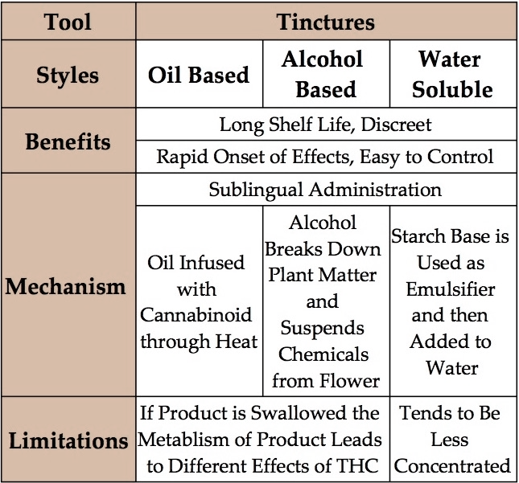  The table below provides highlights and limitations of the various tinctures, as well some popular products. |  | microdosing  Microdosing refers to the practice of consuming small amounts of cannabis in order to maximize the benefits while avoiding psychoactive effects that hinder everyday tasks. Consuming a large dose of cannabis can actually diminish the medical benefits it provides. Microdosing is especially popular among those suffering from depression, anxiety, stress, and pain as it is particularly helpful when attempting to focus or fall asleep.  It is commonly recommended that when attempting to microdose while consuming tinctures that you start with 1ml, working up to 5ml if necessary. Wait at least half an hour when deciding if you need an added dose, if consuming sublingually. Wait an hour if taken orally.  Maintaining a low tolerance for cannabinoids will improve the medical effects and decrease the amount consumed. If you notice yourself consuming a large amount of product and not gaining the same benefit you used to try abstaining from use for 48 hours and then slowly reintroduce the product |  | Mechanism of action  Tinctures are taken sublingually or by adding them to a favorite drink or food recipe. The route of consumption determines the mechanism of action and how the product will affect the user.  Sublingually consumption refers to dropping the desired amount underneath the tongue and allowing the product to dissolve into the bloodstream. Once in circulation the cannabinoids can act on cannabinoid receptors 1 and 2 (CB1 & CB2).  Oral consumption involves ingesting the tincture, allowing the product to be metabolized. The metabolization of cannabinoids results in the formation of metabolites that are then circulated and can act on CB1 and CB2. Be careful to control your dose as metabolites tend to be more potent.

