everything you need to know to buy tinctures  What are cannabis tinctures? Cannabis tinctures refers to various liquids that are infused with cannabis. Tinctures are commonly oil or alcohol based but can occasionally be water-soluble. Tinctures are an easy-to-use and efficient method of consumption, prepared in various ways so that patients can tailor their medication to fit their needs.  This pamphlet contains information on different types of cannabis-based tincture products, products and where to buy them (with discounts!), and useful DIY ideas for different methods of consumption. This pamphlet alose contains information on how to best dose your cannabis tincture, specifically by focusing on microsdosing. |  | Medical Cannabis is Changing the Face of Clinical Medicine.  We are the Leaders of that Change |  | Places to buy tinctures  - Endoca.com  (25% off coupon code: “CED”)  - https://www.TheCBDistillery.com  Vape Pen, Edible, Cream, Tinctures, CBD powder  - https://nuleafnaturals.com  (10% off coupon code: CBD10)  - https://myriamshopehemp.com/  (CBD, CBG, and CBDA, added terpenes, (beta-caryophyllene, myrcene, limonene))  - https://flowerchildcbd.com/  (CBG: 600mg/bottle = 22mg/ml doses)  - https://www.greenmountaincbd.com  “Vermont based hemp growers. Great feedback from the community. ‘cheap and legit’”  - https://www.charlottesweb.com/  - https://rosettewellness.com/  - http://fiddlers-greens.com/  - https://cannakids.org/
 |  | 822 Boylston st  chestnut hill, ma 02467  617-500-3595  cedclinic.com  info@cedclinic.com |  | Check out our blog and social media handles for more information on medical cannabis.  Blog: cedfoundation.com  Instagram: drbenjamincaplan  Twitter: @drcaplan

Types of Tinctures  Alcohol-Based tinctures are created by adding concentrate or decarbylated flower in high-proof alcohol, such as everclear. This is a great way to take advantage of raw cannabinoids, such as TCHA and CBGA. THCA and CBGA are two examples of cannabinoids that cannot be vaporized as heating them would synthesize other cannabinoids.  Oil-Based tinctures are created by infusing cannabis concentrate or flower into a fat, like grapeseed oil. Infusing the oil requires heat which decarboxylates the flower. *These products are great for incorporating into baked goods for a different consumption method. Just substitiue for oil or butter in any recipe.  Water-Soluble tinctures are prepared by adding a starch base as an emulsifier for a cannabis extract and is then added to water.  DIY - Make your own water-soluble tincture at home! If you have an oil- based tincture you’d love to use in a drink at home, you can emulsify it with Gum Arabic. Vigorously blend the gum arabic powder and oil together, and viola! You have a water-soluble product, perfect to use in any smoothie. |  | microdosing  Microdosing refers to the practice of consuming small amounts of cannabis in order to maximize the benefits while avoiding psychoactive effects that hinder everyday tasks. Consuming a large dose of cannabis can actually diminish the medical benefits it provides. Microdosing is especially popular among those suffering from depression, anxiety, stress, and pain as it is particularly helpful when attempting to focus or fall asleep.  While microdosing tinctures, it is recommended to start with 1ml, working up to 5ml if necessary. Wait at least half an hour when deciding if you need an added dose, if consuming sublingually. Wait an hour if taken orally.  Here is a chart for cannabidiol (CBD) for dosing the number of milligrams (mg) in milliliters (ml).  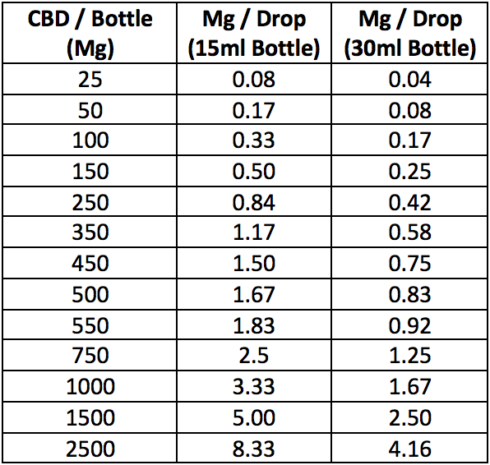 |  | Buying points to consider  - Buying in bulk in more cost efficient. Consider splurging on a larger bottle that will last and end up saving you time and money.  - Consider your desired effect when determining whether to buy whole plant/full spectrum product versus pure CBD, which will not be psychoactive.  - Know how you want to use your product! Do you want to bake with it? Do you want to add in another product for added effects? Do your research.  - *If you currently have tincture but prefer a pill form, don’t waste your product! You can buy empty pill capsules online and fill with the desired product. This is also a great idea for those who wish their favorite tincture was sold in pill form.

