Everything you need to know about Terpenes  What are Terpenes? Terpenes refer to a large class of organic compounds that are produced by a variety of plants and some insects. They most frequently present as aromatic oils that may color the plant they originate from. Terpenes characteristically have a strong odor that accounts for its protective effects in plants.  Many terpenes can be found in cannabis plants and are secreted from the same glands as cannabinoids. Terpenes are responsible for the flavors of specific strains, especially citrus, berry, mint, and pine flavors. Over 100 terpenes have been found in various cannabis plants which are able to interact with other compoenents of cannabis to provide beneficial effects. |  | Medical Cannabis is Changing the Face of Clinical Medicine.  We are the Leaders of that Change |  | 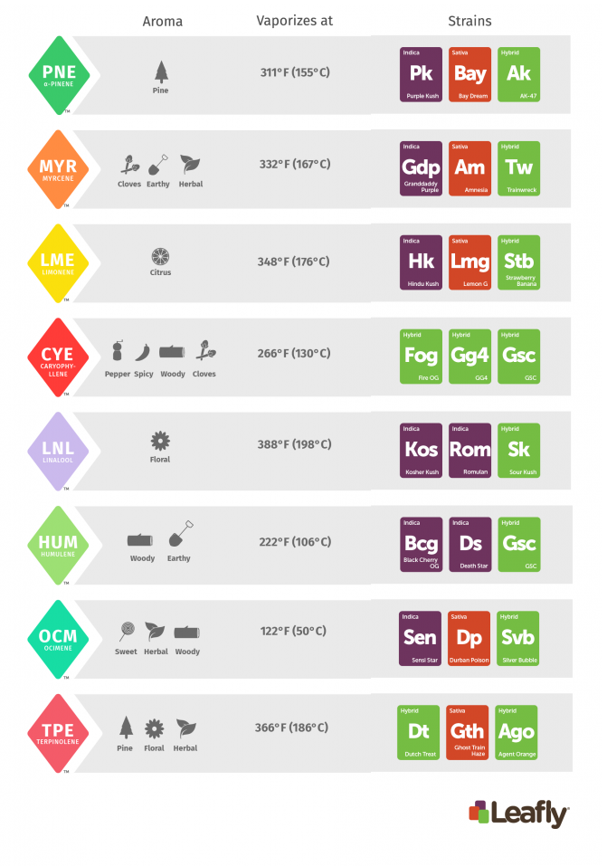
This brochure contains information on popular cannabis terpenes, their therapeutic benefits, and how to best utilize terpenes on an everyday basis. |  | 822 Boylston st  chestnut hill, ma 02467  617-500-3595  cedclinic.com  info@cedclinic.com |  | Check out our blog and social media handles for more information on medical cannabis.  Blog: cedfoundation.com  Instagram: drbenjamincaplan  Twitter: @drcaplan

Cannabis Terpenes |  | WHERE ELSE TO FIND TERPENES  Camphene Nutmeg, Ginger, Rosemary  Caryophyllene Oxide Lemon Balm, Eucalyptus  Isopulegol Rosemary, Peppermint  Limonene Citrust Rinds, Peppermint  Lonalool Lavender  Nerolidol 1 Lemongrass, Tea Tree  Terpinolene Mint, Parley, Basil, Orchids  α - Humulene Cloves, Hops, Basil  α - Pinene Pine Trees  β - Myrcene Hops, Basil, Thyme  β - Pinene Pine, Lime Ginger, Mace  β -Caryophyllene Black Pepper, Cinnamon  β - Ocimene Sage, Romemary |  | The entourage effect  Each terpene has a distinct and unique effect and therefore each terpene is able to interact with cannabinoids in its own way. Terpenes are able to enhance or minimize the effects of the cannabinoid, thereby modifying any cannabis product to better suited the needs of each patient. For example, linalool is known to cause relaxation and may be used in combination with tetrahydrocannabinol (THC) to reduce any feeling of anxiety that can occasionally arise when consuming THC. Or, as another example, you could use a cannabidiol product that features an energizing terpene, such as limonene, to moderate pain more efficiently and stay energized.  Far more research is needed in order to fully elucidate the entourage effect of each terpene on each cannabinoid.

