How to Recognize Quality Bud  What defines quality flower product? It’s easy to determine whether or not the bud in front of you is of a high caliber or something carelessly grown in sub-optimal conditions. Using four of your five senses and adhering to some solid advice, you can become quite the cannabis connoisseur, and may even be able to take on the challenge of discerning different flavor profiles of cannabis.  This brochure contains information on how to determine the superiority of a flower product by looking at the product, smelling the product and determing what exactly that smell means, feeling the structure of the product, and possibly discerning the flavor of the product. |  | Medical Cannabis is Changing the Face of Clinical Medicine.  We are the Leaders of that Change |  | Feeling Flower  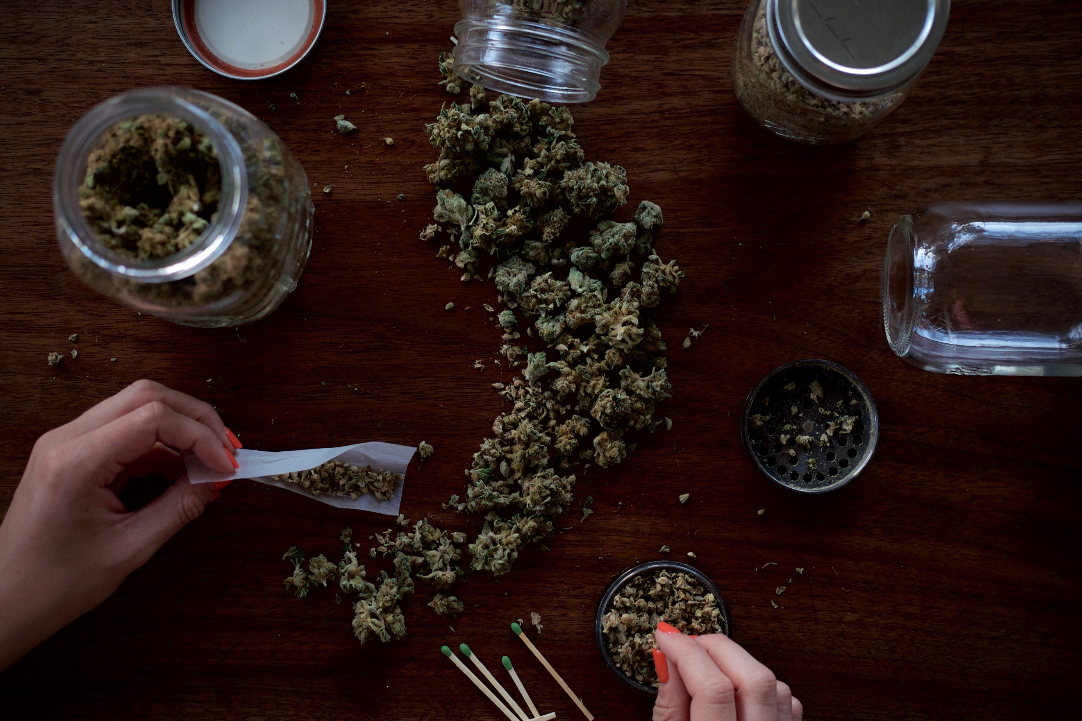  Cannabis flowers are cured after being harvested in order to improve the potency and preservation of the product. Properly cured flower buds should be tacky to the touch and firm. If the product is easily crushed or feels wet, the product was likely not cured properly and should not be consumed.
 |  | 822 Boylston st  chestnut hill, ma 02467  617-500-3595  cedclinic.com  info@cedclinic.com |  | Check out our blog and social media handles for more information on medical cannabis.  Blog: cedfoundation.com  Instagram: drbenjamincaplan  Twitter: @drcaplan

Spotting quality  Trichrome Content – Trichromes are the glands of the plant that have a similar appearance to sugar due to their crystalline structures. There should be many trichromes on your plants, as if it was dipped in sugar.  Color – The color of each plant should be bright and vibrant. If there is a secondary color such as red or purple from the terpene content it should also be vibrant.  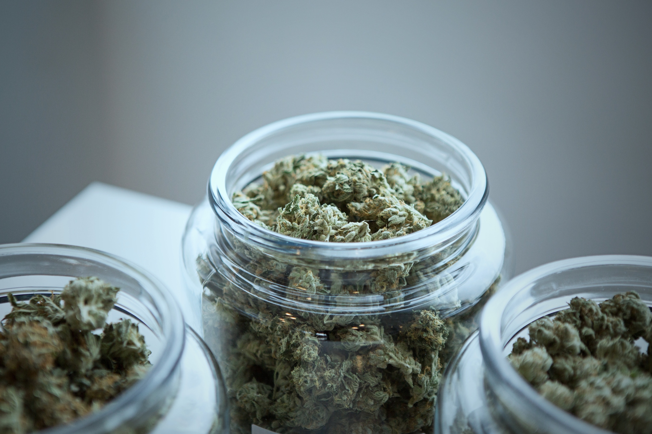  Shape – Vairation in shape between is okay but there shouldn’t be any ovious slashes, cuts, or bald sports on the flower.  Red Flags  - Mildew  - Looks like Baby Powder  - Brown or Grey Decay  - Yellow Stamens  - Banana-like Structures, These Indicate Stress  - Human or Animal Hair |  | Great aromas and tastes  Aroma  Flowers should produce a potent scent as soon as the container is opened.  Expected Aromas and Flavors  Floral Fruit Diesel Fuel  Skunk Pine Earthy  Cheese Candy Citrus  Taste  The taste of cannabis flowers especially difficult to discern, especially for beginners. The taste should match the aroma and be enjoyable. If the taste or aroma is irritating the product is likely of poor quality.  Red Flag Aromas and Flavors  Hey Chemicals  Old Spice Cabinet Lawn Mower Bag  Metallic Mold |  | feeling it out  Be careful when initially trying to self-regulate dosage; start low and go slow.  Users should feel relief from symptoms when consuming cannabis. The “high” associated with psychoactive cannabinoids, such as ∆-9-Tetrahydrocannabinol (THC), should feel like a pleasant lifting sensation. Patients frequently describe the sensation of being ‘high’ as warm, tingly, fuzzy feeling.  The Entourage Effect is a term that refers to the effects felt when cannabinoids and terpenes are consumed together, like when consuming flower, which creates a more well-rounded experience. Patients should inquire about the terpene profile of their product to predict the overall effect of the product. Retailers now frequently categorize their product according to sensation, such as relieve or relax, to make it easier for patients to find their ideal product.

