Hacking Flower: a guide to bud  Flower refers to the whole plant material that is sold as dried buds. Flower product still contains all of the cannabinoids, terpenes, and flavonoids of the plant. The ratio and entourage effect of chemicals in cannabis flowers and products will alter the therapeutic benefits of each product so be sure to discuss what chemical composition is best for you with your physician and budtender.  This brochure contains information on burning and vaping flower product, concentrates to add on to the flower to intensify the effects, and common ways to add those concentrates into your current consumption methods.  Be sure to check out our brochure, “Everything You Need to Know about Vaping” for additional information like ideal vape temperatures for different cannabinoids and how to dose yourself for maximum effects. |  | Medical Cannabis is Changing the Face of Clinical Medicine.  We are the Leaders of that Change |  | Concentrates  Crumble is dried oil with a honey comb like texture.  Badder/Budder refers to concentrate that has been whipped under heat. It’s similar to cake batter in texture.  Shatter is made with a solvent, transluscent and brittle in texture.  Distillate (Oil) is the base of most edibles and cartidges. Odorless and tasteless.  Crystalline is isolated cannabinoids in their naturally occuring crystal structure.  Dry Sift (Kief) is finely milled cannabis with complete trichrome glands.  Rosin refers to to end product of cannabis that has been pressurized under heat.  Bubble Hash is formed by milling flower product through water, ice, and mesh to create a paste.
 |  | 822 Boylston st  chestnut hill, ma 02467  617-500-3595  cedclinic.com  info@cedclinic.com |  | Check out our blog and social media handles for more information on medical cannabis.  Blog: cedfoundation.com  Instagram: drbenjamincaplan  Twitter: @drcaplan

Burning Flower  Smoking flower is one of the simplest ways to utilize cannabis. A quick grind of the product is easy to pack into a bowl or roll into a joint. When smoking flower the product is lit on fire and the plant material is combusted which decaroxylates the cannabinoids, activating the compounds. The active cannabinoids are then introduced to the lungs and are able to diffuse across the tissue into the bloodstream.  Common Methods for Burning Flower:  Joint: Ground up flower bud is rolled, frequently using paper product specifically designed for rolling, and then smoked like a cigarette. Joints are generally meant for singular use making them somewhat unsustainable.  Bowl: A bowl is a blown glass product featuring a chamber to hold the product, a stem to allow airflow, a mouthpiece to inhale the product, and a hole known as the carb that allows the smoke to build up in the stem. Bowls are reusable and often easy to clean. Simply soak the bowl in rubbing alcohol and use salt as an agitator to speed up the process.  Bongs: A bong is a water pipe used to smoke cannabis. Similar to a bowl it has a chamber, stem for airflow and a mouthpiece. Water in the base of the bong filters the smoke that is self-drawn from a bowl with a downstem attatchment. Bongs can also have percolators, carbs, and ice pinches to improve the smoke. |  | Vaping Flower  Vaping refers to process of heating cannabis without burning the product. Heating the product causes the active ingrediants of cannabis to be released in the air as a fine mist of vapor. Vaping is not synonymous with smoking as smoking describes inhaling the smoke of combusted product and is known to contain harmful toxins.  Vaping is more efficient than burning flower, so greater effects are felt when vaping a dose of cannabis in comparison to the same dose being burnt. If switching from one method to the other be sure to change the dose accordingly.  This method of consumption is also great for temperature control. Controlling the temperature that your product is vaporized at will ensure you get the most out of your product.  Classes of Vaporizers  Desktop Vaporizers  These styles of vaporizers are stationary and require access to an outlet.  Portable Vaporizers  These styles of vaporizers are portable and the vapor is self drawn.  Find out more in our brochure, “Everything You Need to Know About Vaping” | 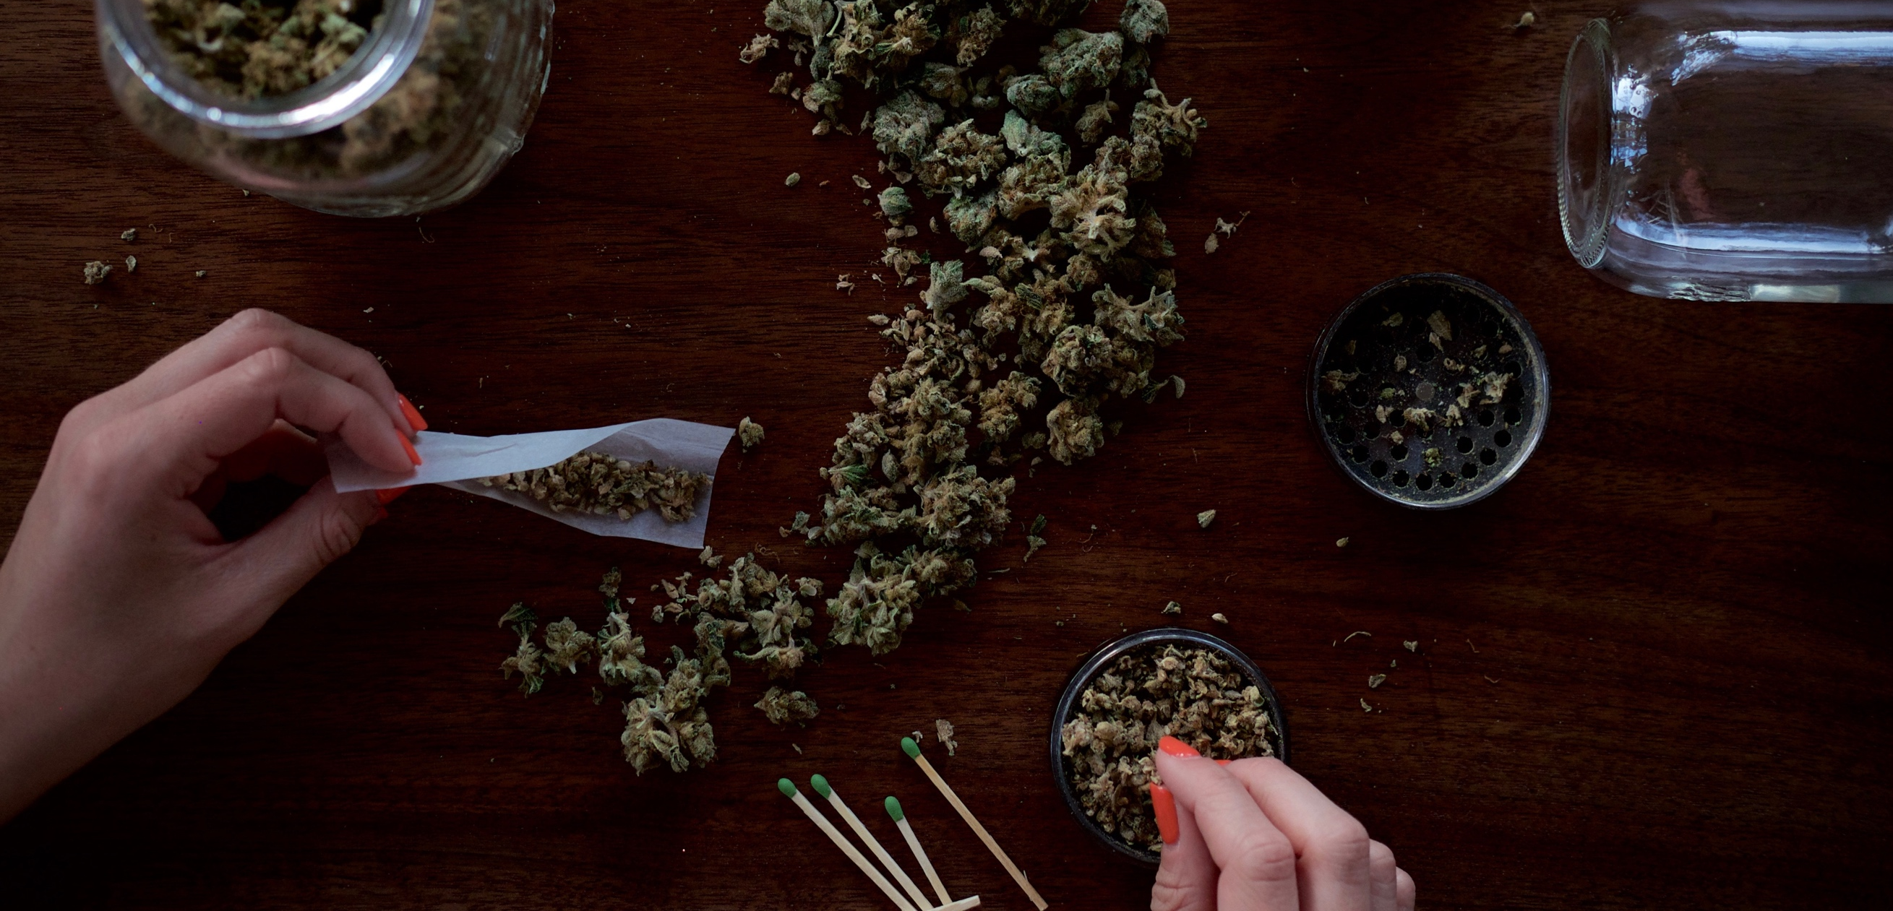  Potency | how to increase the potency  - Sprinkle kief on top of the ground up flower in a bowl or vape.  - Roll a thin rod of concentrate into a joint in the center of your bud product.  - Dip the flower product in distillate before grinding and then enjoy in your favorite bowl or vape.  - Pack the bowl with bud and shatter concentrate.  - Enjoy a Thai Stick for maximum benefits. A Thai Stick is a cigar made entirely from cannabis product that boasts an outrageous high. Nuggets of zbud are skewered on a plant stem dipped in has oil and held together with hemp string. Then a marijuana leaf is wrapped around the bud and string and left to cure.

