Everything you need to know about edibles  What are edibles? Edibles are one method of consuming cannabis product that does not require inhalation or respiratory action. Many users are drawn to edibles as the doses are easier to control, they are more discreet than vaping, and there is no risk of lung irritation. Edibles are generally made from a fat infused cannabis product, such as butter, that is then baked into a common food or added to a beverage. Common examples are cookies and lattés.  This brochure contains information about common types of edibles, their benefits and limitations, how to correctly dose yourself (specifically microdosing), and what chemicals are featured in widely available edible products. |  | Medical Cannabis is Changing the Face of Clinical Medicine.  We are the Leaders of that Change |  | metabolism of edibles  Edibles differ from inhalation and tinctures that are dissolved under the tongue because, rather than have the cannabinoid enter directly into the bloodstream, the cannabinoids are first processed, or metabolized, in the digestive system. By first metabolizing the cannabinoids users are actually circulating a product formed from the cannabinoids, known as metabolites. The metabolic process is part of the reason edibles take longer to affect users. Metabolites is a term that describes an end or intermediate product of metabolism and is not specific to cannabis. The metabolites act on the endocannabinoid system differently than other products and are frequently more potent that the original cannabinoid.
 |  | 822 Boylston st  chestnut hill, ma 02467  617-500-3595  cedclinic.com  info@cedclinic.comEmail |  | Check out our blog and social media handles for more information on medical cannabis.  Blog: cedfoundation.com  Instagram: drbenjamincaplan  Twitter: @drcaplan

Types of edibles  Foods and Liquids: Edibles in the form of foods and liquids are extremely versatile as cannabis flower is normally infused into a fat (like butter) and then added to a variety of foods and drinks, such as brownies and hot chocolate.  Pills, Capsules, & Tablets: Pills, capsules, and tablets are known doses of cannabis product concentration into small products for ease and discretion. People commonly choose to consume cannabidiol (CBD) in the form of gummy vitamins.  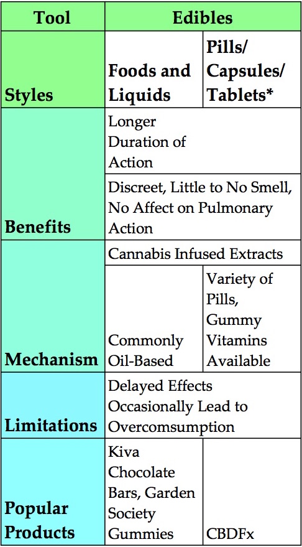  The table below provides highlights and limitations of the various edibles, as well some popular products. |  | Common Cannabinoids featured in edibles  Cannabidiol (CBD) and ∆-9-tetrahyocannabinol (THC) are most likely to be the main active ingredient featured in the typical edible. Speak to the physician who recommended cannabis use or approved your medical card in order to determine which cannabinoid would be best for you. THC is known to have psychoactive effects which limits its use as it interrupts those attempting to go about their dialy lives. CBD does not have a psychoactive component but is not always the best option for some patients, depending on their circumstances. Edibles, just like various flowers and concentrates of cannabis, often contain a ratio of THC and CBD. Speaking with your physician and slowly finding out what works for you is an important part of consuming cannabis.  CBD and THC is commonly incorporated intp an edible form from a dystillate made from an infused oil or other fat, but occasionally a concentrate, like kief, is used as well. |  | Microdosing  Microdosing refers to the practice of consuming small amounts of cannabis in order to maximize the benefits while avoiding psychoactive effects that hinder everyday tasks. Consuming a large dose of cannabis can actually diminish the medical benefits it provides. Microdosing is especially popular among those suffering from depression, anxiety, stress, and pain as it is particularly helpful when attempting to focus or fall asleep.  There is no definite dosage chart to follow for microdosing cannabis due to the various chemical compositions and people processing those chemicals at different rates. It is commonly recommended that when attempting to microdose while consuming edibles that you start with 2.5mg, working up to 10mg if necessary. Wait at least an hour when deciding if you need an added dose.  Maintaining a low tolerance for cannabinoids will improve the medical effects and decrease the amount consumed. If you notice yourself consuming a large amount of product and not gaining the same benefit you used to try abstaining from use for 48 hours and then slowly reintroduce the product.

