Cooking with cannabis (GF)  Cooking with cannabis is great way to customize your consumption method. Whether you’re using a distillate, tincture, or other concentrate in the kitchen, there is an easy way for you to incorporate cannabis into your diet. Salad dressings, cocktails, smoothies, your favorite dinner, and the classic, baked goods. The myriad of cannabis-based products available allows for the complete customization of any edible.  This brochure has been designed to lend a helping hand and suggest some trusted recipes to get you started cooking with cannabis in your own home. In this pamphlet is everything you need to know to start cooking with cannabis; what products are easiest to cook with, how to incorporate them into recipes, and even an example recipe |  | Medical Cannabis is Changing the Face of Clinical Medicine.  We are the Leaders of that Change |  | Sweet potato hummus  Cut one large sweet potato into cubes and place onto a baking sheet with 2 smashed cloves or garlic. Drizzle with olive oil and roast at 375ºF for 40-45 minutes. Once cool, blend until smooth in a food processor. Add 3 tbsp. Tahini, the juice of one lime, and salt to taste. Blend again and serve with a drizzle of oil.  How to add cannabis: Get a known dose of your favorite of cannabis-based oil or butter. Use the oil as the final drizzle for the hummus. If one potato is too much hummus for you the recipe is easy to scale back into a single serving. Try cutting all the ingredients in half and enjoy with veggies or a favorite chip!
 |  | 822 Boylston st  chestnut hill, ma 02467  617-500-3595  cedclinic.com  info@cedclinic.com |  | Check out our blog and social media handles for more information on medical cannabis.  Blog: cedfoundation.com  Instagram: drbenjamincaplan  Twitter: @drcaplan

oil-based cannabis  Oil-based cannabis products like oil-based tinctures and dystillates are great for baking and cooking with because they can be substitued for most fats in receipes. For example, if your favorite brownie recipe calls for ½ cup of vegetable oil, simply fully replace with ½ cup or partially replace with a smaller amount of concentrated oil to lower the dose. (Tip: Make a single serving of your favorite snack to fully control the dose. A suggested recipe is on the other side of the page.)  Salad dressing are another easy way to substitute cannabis concentrate in for an ingrediant like olive oil. Most distyllates are mild in flavor, or you can buy a tincture that features the terpene limonene which will taste citrusy, making them perfect to incorporate into a light balsamic or citrus flavored dressing.  Get creative! If you have an awesome recipe for butter chicken or sautéed vegetables, try cooking, or just garnishing with cannabis-based oil or cannabutter. Some dispensaries offer grapeseed oil infused with cannabis, which is a very mildly flavored oil that’s great for cooking. Check out Elevation Oil at New England Treatment Access (NETA), which has a high smoke point perfect for cooking but is also recommended for smoothies. |  | cocktails  Oil-based tinctures can easily be made water soluble. Some water-soluble tinctures are available online or in stores but they can be difficult to find. To make your favorite tincture water-soluble at home, simply blend up with an emulsifier such as Gum Arabic. Emulsifying the cannabis-based oil with Gum Arabic makes it easy to incorporate the product into any cocktail recipe. Emulsifying with any product will slightly dilute the known dose of the oil, so try making the solution as needed. That way, the dose you use is known and can just be used to make the current batch of drinks.  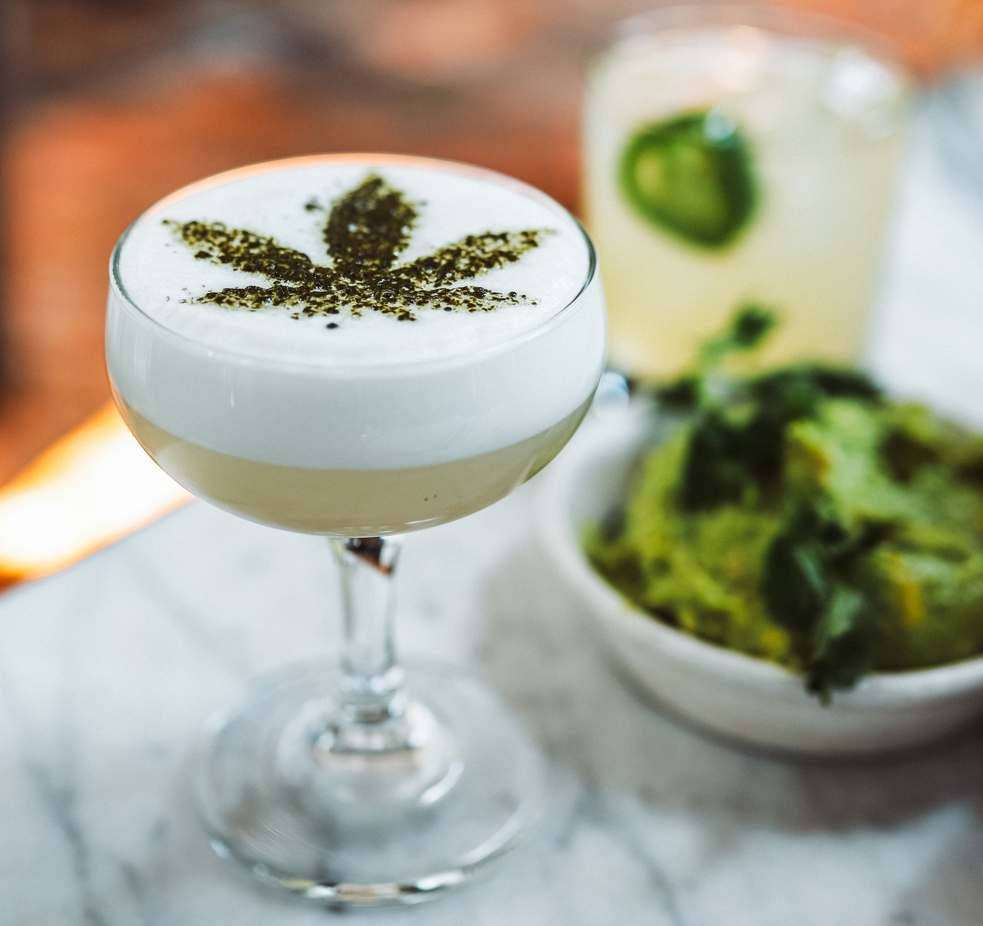  Make the desired cocktail as directed and then thoroughly mix in your known dose of emulsified tincture. |  | ‘Green’ granola  In an oven heated to 350ºF place:  - ½ cup slivered almonds  - ½ pumpkin seeds  - 2 tbsp. of sesame seeds  Toast for 5-7 minutes, then reduce oven to 275º.  While the nuts are toasting whisk together:  - ½ cup of honey  - 3 tbsp. of favored nut butter  - 3 tbsp. of vegetable oil  - ½ tsp. orange zest  - 1 tbsp. orange juice  - 1 tsp. vanilla extract  Once nuts are toasted stir together with honey mixture and 2 cups of old-fashioned oats and a pinch of salt.  Bake all together for 20-25 minutes, stirring occasionally. Once out of the oven stir in ½ cup each of dried cranberries and chopped apricots. Let cool and enjoy.  How to Incorporate Cannabis: Substitute some of the vegetable oil with the desired dose of cannabis concentrate.  This recipe is completely customizable to your needs so experiment to find what works best for you.

